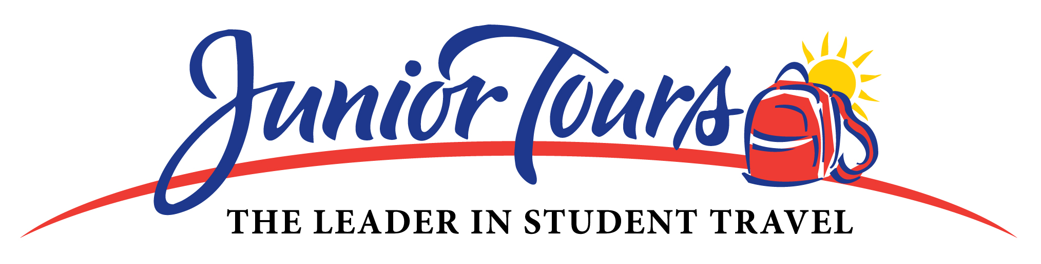

Registration Form
Dear Students & Parents: You are invited to participate in an exciting and educational trip of a lifetime! To register, (1) fill out the form completely, (2) review the “Terms and Conditions”, (3) sign the bottom and (4) submit to your Group Leader with 1st deposit before the due date. Space is limited and seats will be reserved on a first come, first served basis. Please contact your Group Leader with any questions.

GROUP NAME: Hayfield Secondary School DESTINATION: New York City
GROUP LEADER: Meghan Nugent TOUR DATES: April 9-10, 2010

TOUR PRICE: $529.00 per person – quad occupancy (based on a group of 35+ paying participants)

1ST DEPOSIT: $150.00 per person 1ST DEPOSIT DUE: 10/1/2009
2ND DEPOSIT: $150.00 per person 2ND DEPOSIT DUE: 12/1/2009
BALANCE: $229.00 - quad occupancy BALANCE DUE: 2/1/2010
$254.00 - triple occupancy
$269.00 - double occupancy
$309.00 - single occupancy

* Do not staple your check to this form or any other. PLEASE MAKE CHECKS PAYABLE TO HAYFIELD DRAMA.

YOUR TOUR PACKAGE INCLUDES:
- Round-trip transportation
- Private motorcoach for all local touring
- Deluxe hotel accommodations
- Tour Escort with group 24 hours a day
- Breakfast and dinner each day on tour
- All admission fees and taxes
- Evening activities
- Tickets to 2 Broadway Shows
- Night time security

JUNIOR TOURS - THE LEADER IN STUDENT TRAVEL:
- Founded by a New York City school teacher in 1967
- Specializing exclusively in overnight educational tours
- Active member of the National Tour Association since 1986
- Each Tour Participant is given an Emergency Procedure Card
- A Tour Representative is available 24 hours a day / 7 days a week
- Liability insurance coverage
- 9 out of 10 groups who travel with Junior Tours return for another tour
- Junior Tours has successfully planned tours for over a half million students

Name of Registrant exactly as it appears on ID: __________________________________________________________
Date of Birth: ______________ Male □ Female □ / Student □ Adult □
Street Address: _______________________________________________ Home Phone: ______________________
City: _____________________ State ________ Zip __________________ Parent Cell Phone: __________________
Parent Email Address: __________________________________________ Do you prefer bills: Mailed □ Emailed □

By signing below I understand and agree to the Junior Tours Terms and Conditions appearing on the other side of this page.

___________________________________________________ _________________________________ ______________
Signature of Participant (if 18 or older) or Parent/Legal Guardian Printed Name Date

- TERMS AND CONDITIONS -

Tour Price: The Tour Price is based upon an agreed to minimum number of full paying travelers and specific activities as set forth on the sample itinerary. Failure to reach the minimum number of paying participants and/or the addition of new activities to the Tour may necessitate an increase to final Tour Price. Junior Tours reserves the right to pass along to the Group any and all unforeseen increase in supplier cost (e.g. fuel surcharges, taxes or fees) imposed by airlines, motorcoach companies and other common carriers and/or vendors. Fees for airline checked baggage are not part of tour package and due at airport check in

General Payment Procedures: Your completed Registration Form and 1st Deposit must be turned into the Group Leader by the date indicated on the other side of this form. Only one registrant per form. Your canceled check is your receipt. There is a $25 fee for all returned checks.

Refunds & Cancellations: ALL PAYMENTS ARE NON REFUNDABLE. If you choose to cancel from the Tour and can find a new replacement, your deposit can be transferred in full to the new replacement’s account. Transfers can not be made to a person who is already registered for the Tour. For groups that are flying, name change fees may apply if the list of registrants has been submitted to the airlines, usually about 60 days before departure.

You have the option of purchasing the “Travel Protection and 24 Hour Assistance for Travelers” Insurance offered through Berkely-ARM Inc. The optional insurance provides a full refund of all monies paid to Junior Tours in the event that sickness or injury to yourself or immediate family member prevents you from traveling. The insurance also includes coverage for trip interruptions, baggage protection and limited medical expenses. Applications with full details of this policy are available through your Group Leader.

Forms are also available for download at www.juniortours.com/images/jr_tours_NTA_insurance_mailer_text.pdf

Medical History & Release: You must submit to your Group Leader a complete and accurate Medical History & Release which they may send to Junior Tours. Any medical or physical conditions that chaperones should know or that may interfere with your participation on the Tour or with others on the Tour must be stated on the Form. I authorize the adults on my Tour to obtain emergency treatment as deemed necessary by medical professionals.

Conduct Expected: Participants are responsible for exercising sound judgment, caution and respect for people, places and things while on tour. A guideline of expected behavior is outlined in the "Rules and Regulations" as posted on our website at www.juniortous.com. Failure to comply with the Rules as set forth by the Group Leader and chaperones may result in the participant being sent home at own expense with no refund. Each Tour Participant is responsible for paying for any damage to the hotel, motorcoach or other property caused while on tour.

Arbitration: Any controversy or claim arising out of or relating in any way to these Terms and Conditions or any other information relating in any way to our Tour, or the Tour itself, shall be settled solely and exclusively by binding arbitration in Newark, New Jersey in accordance with the commercial rules of the American Arbitration Association then existent.

Responsibility Clause: Junior Tours, its employees, shareholders, directors, agents, (collectively “Junior Tours”), your school, group leaders, chaperones, Board of Education, (collectively, “Group Leader”) does not own, operate or control any person or entity which provides goods or services for your Tour including , for example, lodging facilities, transportation companies, guides, entertainment or sightseeing operators, restaurants, etc. All such persons and entities are independent contractors. As a result, neither Junior Tours nor your Group Leader is liable for any negligent or willful act on such person or entity, or of any third party.

Without limitation, neither Junior Tours nor the Group Leader is responsible for any injury, loss or damage to person or property, death, delay or incontinence in connection with the provision of any goods or services whether occasioned by or resulting from, but not limited to, acts of force majeure, war, civil unrest, insurrection, strikes or other labor activities, criminal or terrorist activities of any kind, lost or stolen belongings, overbooking or downgrading of accommodations, mechanical or other failure of airplanes or other means of transportation or for any failure of transportation mechanism to arrive or depart timely, dangers associated with animals, sanitation problems, food poisoning, lack of quality of medical care, illness or disease, difficulty in evacuation in case of medical or other emergency, or for any other cause beyond the direct control of Junior Tours or your Group Leader.

Changes in hotels or itinerary may be made at the discretion of Junior Tours if deemed necessary or desirable. Any likeness (video or photo) taken of a Tour Participant or any statement or comment made by a participant of a tour with Junior Tours may be used in materials published by Junior Tours without compensation. Junior Tours reserves the right to decline to accept or retain any person as a member of any tour. Junior Tours reserves the right to cancel any Tour with its sole obligation to refund all monies received by it for the Tour. Junior Tours is not responsible for any lost or stolen items while on Tour.

